GitHub repository where all documentation & code can be found. [billbill100 (github.com)](https://github.com/billbill100)

**Installing CP2102 or CH340 USB Driver. V1.3 28/07/2024**

**Note**:- The Lolin D32 board uses the CH340 driver  
 The NodeMCU32 board uses the CP2102 driver.  
  
Depending on what project you are building and what ESP 32 board is used (Lolin D32 or NodeMCU32) will depend on which of the two drivers need to be installed on the computer.  
  
The CP2102 device driver does not normally come pre-installed on Windows and has to be installed manually.  
If using a ESP32 board with a different driver, Windows may or may not have a driver pre-loaded.  
  
The CH340 driver will normally be installed on a Windows computer.   
Follow the below to see if Windows has the CH340 driver. If not, skip to the end of this document for CH340 specific instructions

**Connect the ESP32 board** to the computer using a suitable USB cable.

**Open Device Manager** by pressing Windows Key + X and selecting ‘Device Manager’

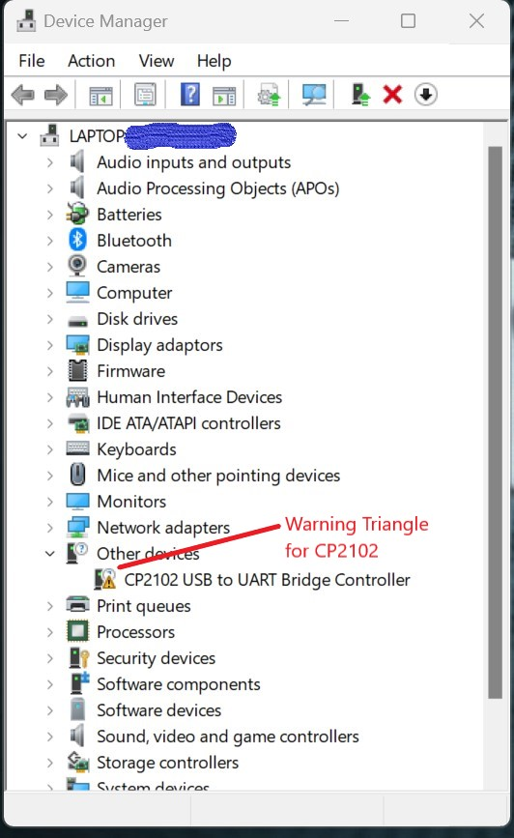

If you see a yellow ! triangle labelled CP2102, then drivers require installing.

Note:- the Ports (COM & LPT) may need expanding, to see the device.

**Note:- if using a board with the CH340 USB device (Lolin D32) & the above is not showing it as working, skip to the end of this document for CH340 specific guidance.**

**Step 1,**

Download the drivers from the link below.

Fow Windows users, select the top one, CP210x Universal Windows Driver

[CP210x USB to UART Bridge VCP Drivers - Silicon Labs (silabs.com)](https://www.silabs.com/developers/usb-to-uart-bridge-vcp-drivers?tab=downloads)

**Step 2**,

Navigate to the downloaded file (most likely in Downloads directory) Highlight it by clicking once, then right-click and select ‘Extract All’ and accept the default directory.

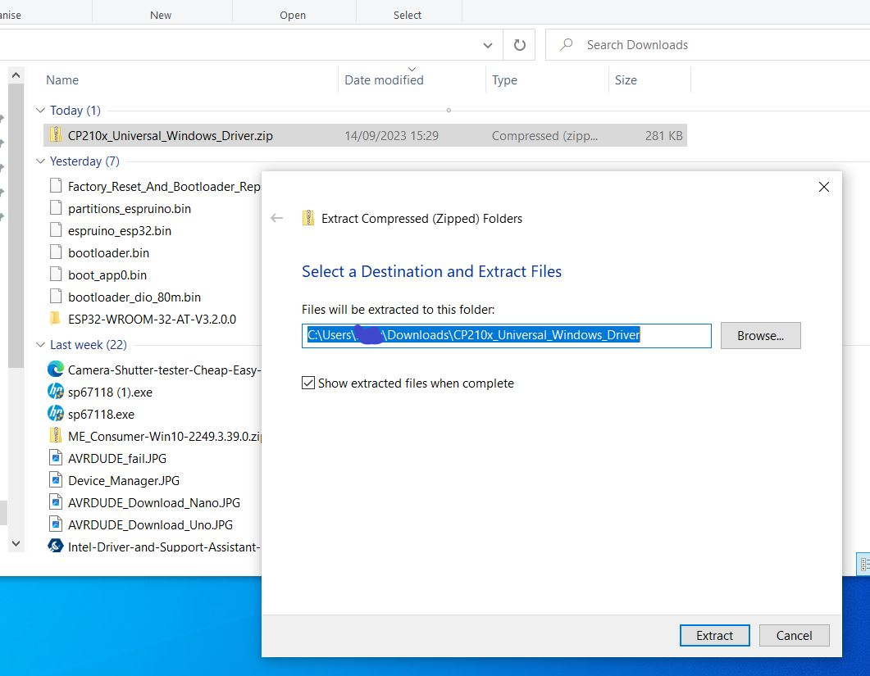

**Step 3,**

Go back to Device Manager and right-click on the Yellow ! Triangle   
select ‘Update Driver’ and then ‘Browse my computer for drivers’

Click ‘Browse’ and navigate to the Downloads folder, find and click on the folder that was previously downloaded & extracted.

Click ‘Ok’ and then ‘Next; in the previous box and the drivers should be installed.

A computer re-start will be required to complete installation.

**CH340 Specific Instructions.**  
  
If the CH340 driver is not loaded & Windows is not showing an option to automatically install it, follow the link below for a video guide.

[How to Install CH340 Drivers - SparkFun Learn](https://learn.sparkfun.com/tutorials/how-to-install-ch340-drivers/all)